Match the blocks with the proper menu name:

 |  | - Pen
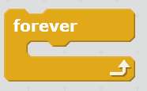 |  | - Operators
 |  | - Data
 |  | - Sound
 |  | - Control
 |  | - Motion
 |  | - Events
 |  | - Sensing
 |  | - Looks

